Task1 Report

Submited by : Giresh (16137268)

Subtask 1 : TI Sensor Tag with Android Sensor Tag

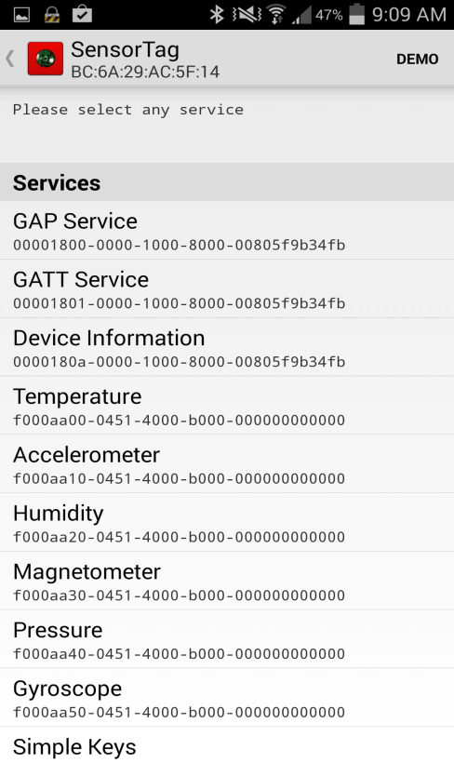Downloaded the BLE Sensor tag app from the Google play. The BLE sensor tag is connected to the sensor tag via blue tooth to see the reading in the app

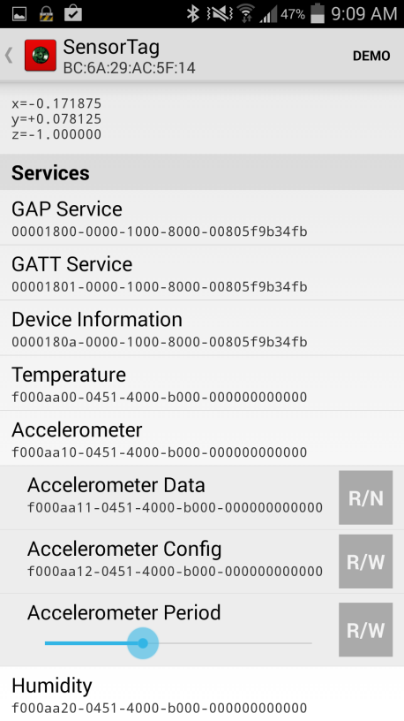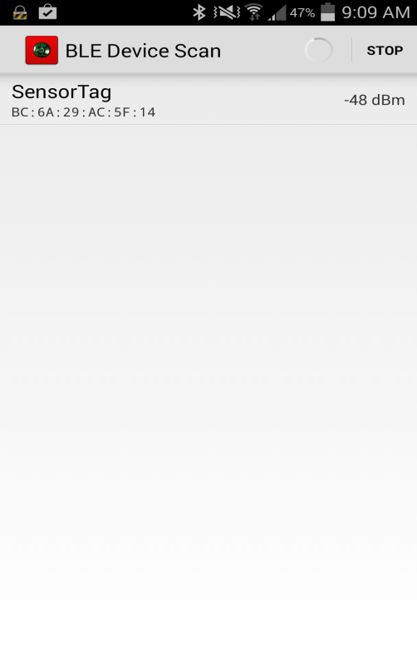

After downloading and open the source code file Android-Sensortag, connected to the device via wire and install the app in the device

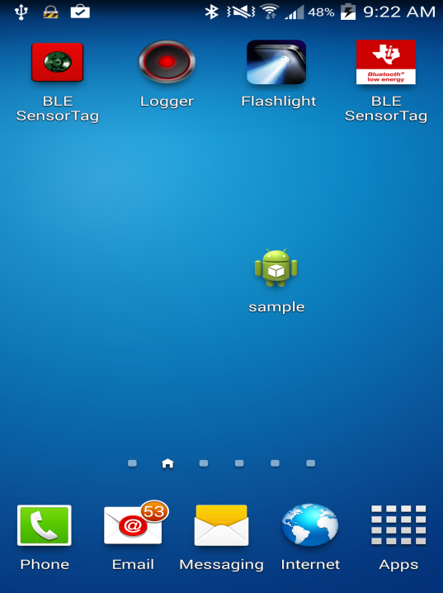

The given source code file is opened and the device is connected to sensor tag via blue tooth the, the data is read from the device via Bluetooth and can be seen in the log file of the ap in ADT.

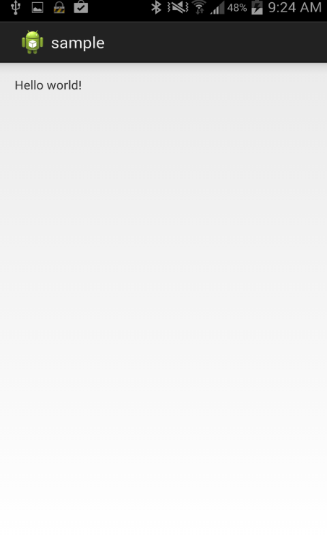

The Sensor tag reading from the log file

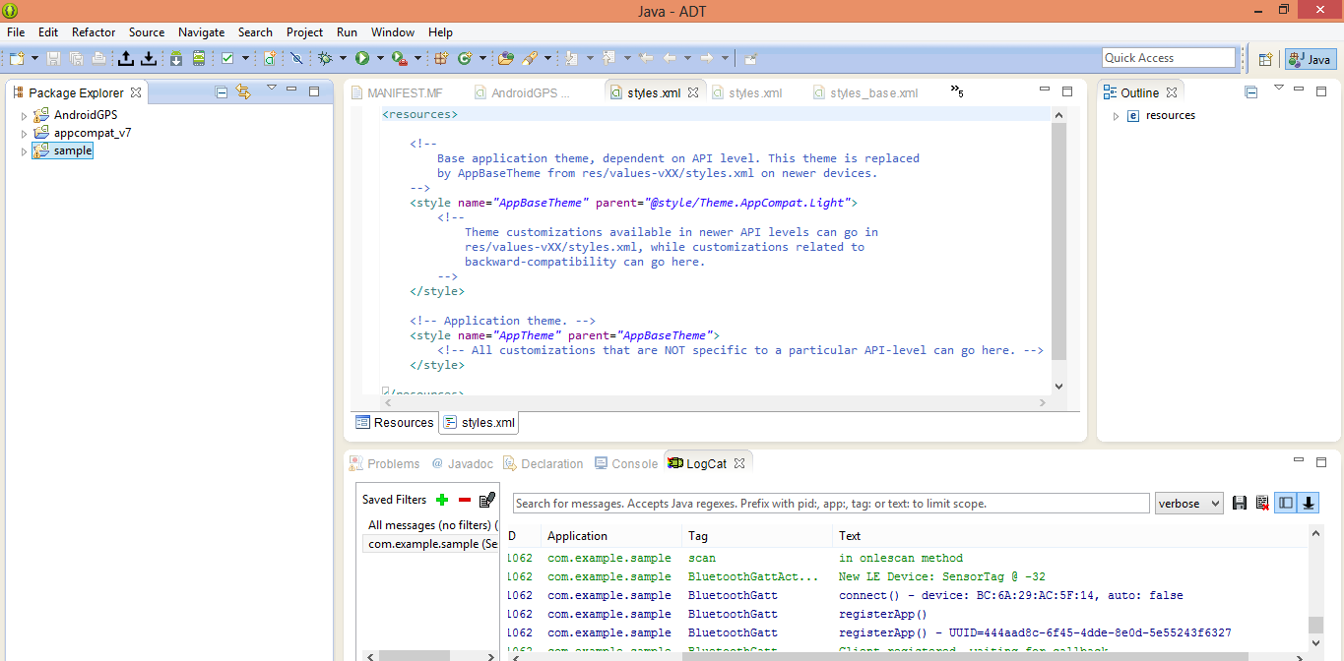

Subtask2. Mobile sensor with Android App.

The source is downloaded from blackboard and is opened in Eclipse ADT, the app is installed into the device and when it is opened it reads the data from the inbuild sensors, which we can see the color change in the screens when the device is shaken

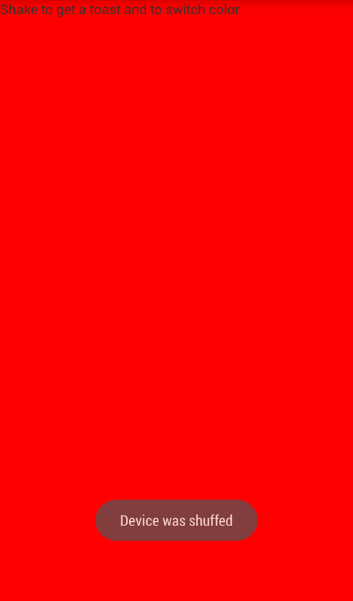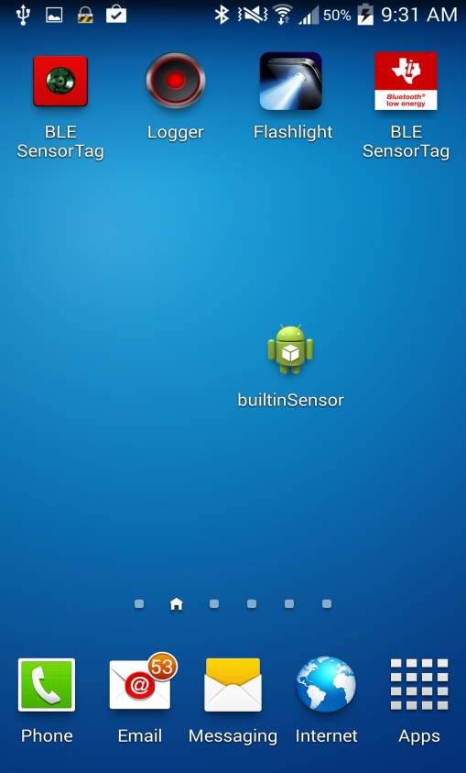  
initially the screen is green and due to changes in the internal gyroscope data the screen changes to color red and leaves a toast that is device is shuffled

Subtask 3: GPS Feature with Android Smart phone.

The given source code is downloaded from the black board and opened in Eclipse ADT, to make the necessary required changes.

This app collects the data from the in built device GPS of android device and mentions the latitude and longitude and the Address of the location

Initial Location of the device

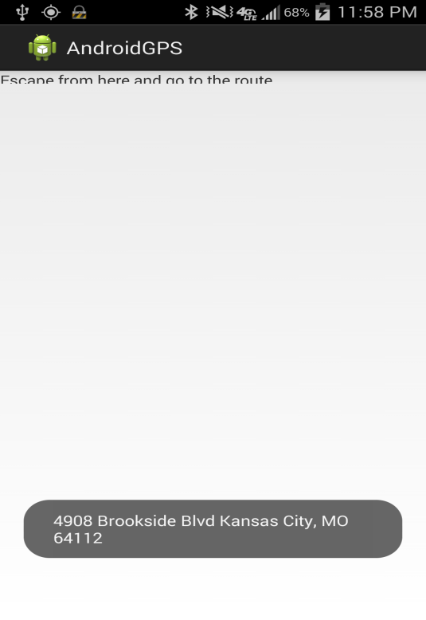

Upon the change of location

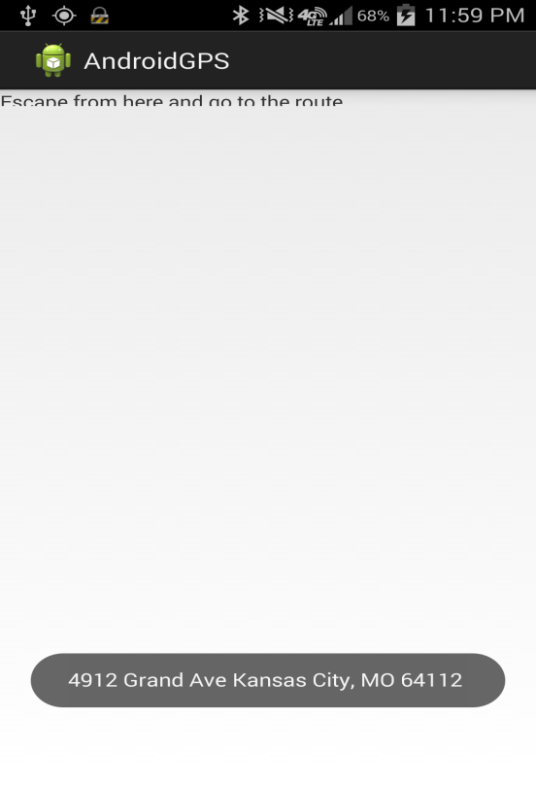

The latitude and longitude of the device location

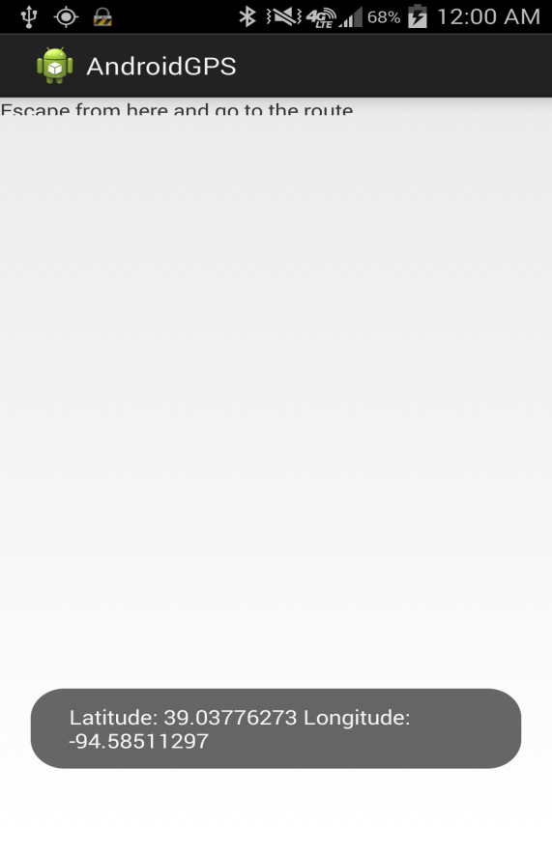

Sub Task 4:

Wiigee app with android smart phone

Subtask 5: TI Chronos watch with JAVA App

After downloading and installing the control center from the CD, the chronoswatch is connected to the control center in ACC mode via a RF receiver. The changes in the orientation and movement of device is recorded in all the three dimensional axes

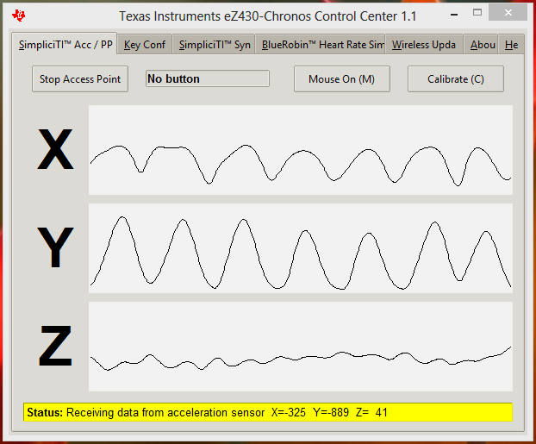

The Punch game is installed into PC and is connected to the Chronos watch via RF receiver which takes the readings

Due to RF connector problem we are unable to play the game but however we are ble to get the readings from the device

